USER GUIDE
Active Directory
Access Report
Find out who has access to what — run the report, read it, and attach it to the ticket.
For: anyone asked to check who has access to what. No Active Directory experience needed.
Tool: Run-AccessReport.bat (runs Export-ADGroupMembership.ps1)
Updated: October 2026

NOTE How to use this guide
Sections 1 to 4 take you from nothing to a finished report in about five minutes. Sections 5 to 8 explain each tab of the report. Section 9 has step-by-step recipes for the questions you will be asked most. If something goes wrong, go to section 10.
The last page is a quick reference card you can print and keep by your desk.
Every name, group and screenshot in this guide comes from a made-up company (Contoso). Your report will show your own directory.

Contents
1. What this tool does 3
2. Before you start 4
3. Running the report 5
4. When it finishes 10
5. People tab — what does this person have? 12
6. Groups tab — who is in this group? 14
7. Overlap tab — which groups share people? 16
8. Nesting tab — groups inside groups 19
9. Common tasks 21
10. Troubleshooting 23
11. What to put in the ticket 25
Quick reference card 26

1. What this tool does
The AD Access Report reads Active Directory and produces a report showing every person, every group, and how each person got into each group. It answers questions like:
- What can Sofia get into?
- Who is in Domain Admins?
- If I remove Marcus from VPN-Users, will he really lose VPN access?

Use it to
- See every group a person is in — including groups they get through other groups.
- See everyone in a group, and how each of them got there.
- Spot people who have the same access twice (removing one route will not remove their access).
- Find groups that have almost the same members — candidates for a clean-up.
- See which groups are inside which, including loops and groups placed inside Domain Admins.
- Attach one file to a ticket as evidence for an access review or an offboarding check.

It does not
- Change anything. It only reads. Running it never adds, removes or edits a user, group or setting.
- Show folder or file-share permissions. It shows which groups people are in, not what each group is allowed to open.
- Show Microsoft 365 / Entra ID cloud-only groups, or groups in other domains.
- Include disabled accounts. A disabled person simply does not appear (your AD admin can include them if needed).

Who does what
Your AD admin in this guide means whoever looks after Active Directory where you work — a senior engineer, a systems team, or an outside IT provider. If you are not sure who that is, ask whoever gave you this tool.
Task | You | Your AD admin
Run the report (any menu option) | ✓ | ✓
Read the report and answer "who has access" questions | ✓ | ✓
Attach the report to a ticket | ✓ | ✓
Install the Active Directory tools (RSAT) on a computer |  | ✓
Fix "could not reach a domain controller" after the basic checks in section 10 |  | ✓
Run with extra options (disabled accounts, a different domain controller) |  | ✓
Add or remove people from groups | Only if your role allows it, through your normal change process | Through your normal change process

2. Before you start
Tick these off before you run the report. Each one takes a few seconds to check.
- You are signed in with a domain account (for example CONTOSO\your.name), not a local account.
- The computer is on the company network, or connected to the VPN.
- You have the whole report folder. It must contain all three of these files, side by side:
  - Run-AccessReport.bat
  - Start-AccessReport.ps1
  - Export-ADGroupMembership.ps1
- The computer has the Active Directory tools. Domain controllers and most admin servers already do. If not, the tool tells you straight away (see section 10).
- You know what question you are answering: everyone, a few named groups, or one department.

TIP You do not need administrator rights
Any domain account that can read the directory can run the report. It works on Windows Server 2012 and newer, and on Windows 10 and 11.

3. Running the report

Step 1 — Copy the folder
Copy the whole report folder to the computer you will run it on — the Desktop or C:\Tools is fine. Do not copy just one file: the three files work together.

Step 2 — Double-click Run-AccessReport.bat
A black PowerShell window opens. Everything happens in this window; there is nothing else to install or configure.
IMPORTANT If a blue "Windows protected your PC" box appears
Stop and ask your AD admin. Do not click through it. Files copied from your team's own share normally do not show this.

Step 3 — Wait for the checks
The tool first checks that the computer is ready. You should see three green [OK] lines:
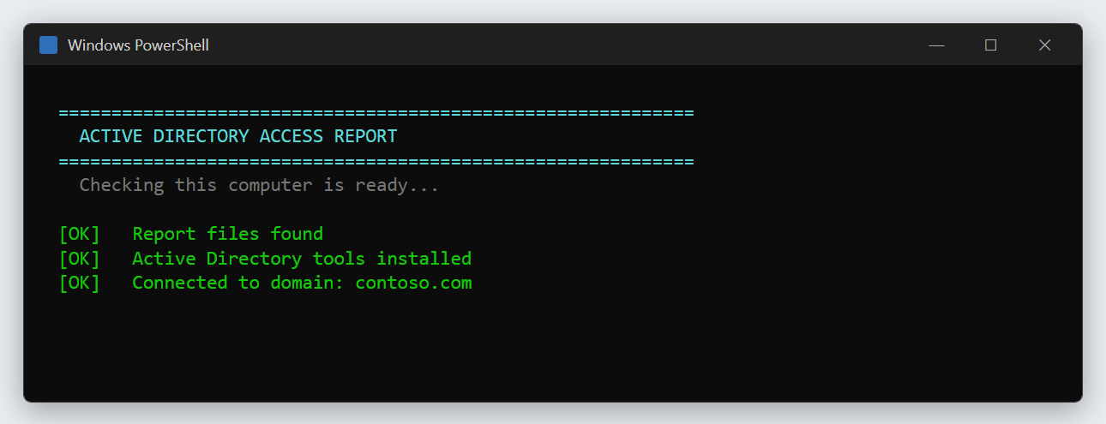
Figure 1 — The readiness checks. Three green [OK] lines means you are good to go.
If a check fails, the window turns red, explains the problem in plain English and waits for you. Nothing has been run. See section 10 for what each message means.

Step 4 — Choose what to report on
Next you see the menu. Type a number and press Enter.
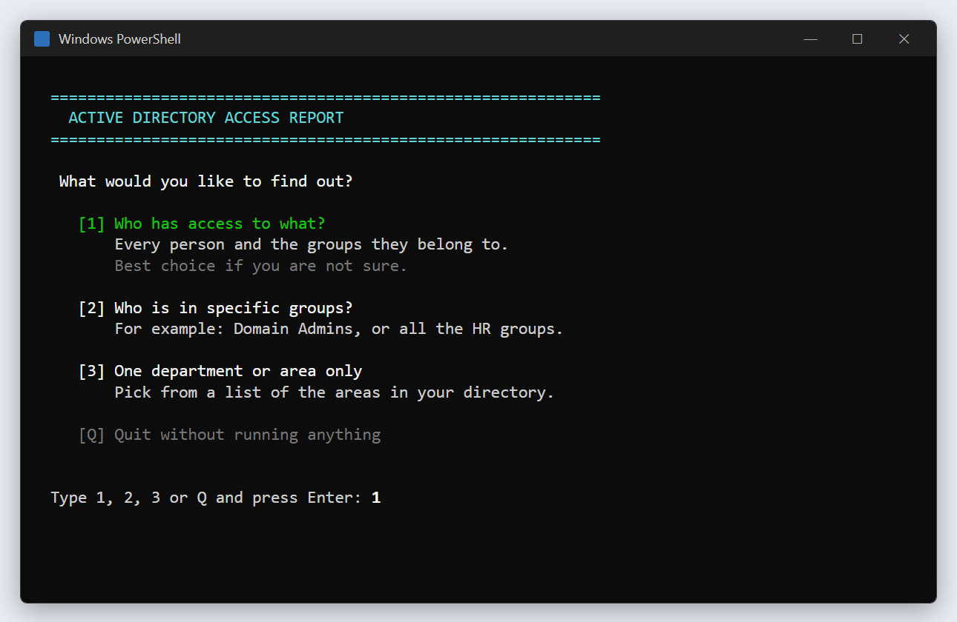
Figure 2 — The main menu. Option 1 is the right choice most of the time.
Option | Choose it when… | What you type
1 Who has access to what? | You are not sure; an access review; an offboarding check; "what does this person have?" | Just 1
2 Who is in specific groups? | You were asked about particular groups, such as Domain Admins or the HR groups | Group names separated by commas
3 One department or area only | You only need one part of the directory (one department's folder in AD) | The number next to the area
Q Quit | You opened it by mistake | Q — nothing is run

TIP If in doubt, choose 1
Option 1 covers everything, and the report has filter boxes on every tab, so you can still find one person or one group in seconds.

If you chose option 2 — named groups
Type the group names separated by commas and press Enter. To include every group that starts with the same letters, end the name with * — for example HR-* gives every group whose name starts with HR-.
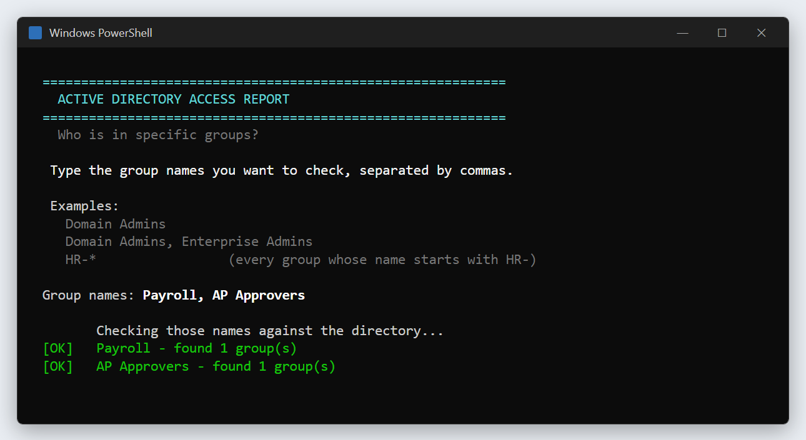
Figure 3 — Option 2. Each name is checked against the directory before the report starts.
Each name is checked straight away. A green [OK] means the group was found. A yellow [!] … no group found with that name usually means a typo — the report still runs for the names that were found. If none of the names match, the tool asks whether you want to type them again.

If you chose option 3 — one area
The tool lists the areas (folders in Active Directory) that contain groups, with how many groups each holds. Type the number of the one you want, or B to go back. Only the first 20 areas are listed; if yours is missing, go back and use option 1.
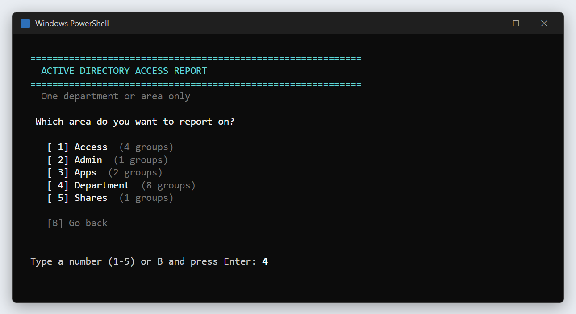
Figure 4 — Option 3. Pick an area by number — no typing of directory paths needed.

Step 5 — Let it run
The report starts. Lines scroll past as it works through each group — that is normal. A yellow [WARN] line such as "no members" is information, not a problem. Do not close the window while it runs: a small directory takes under a minute, a large one can take several minutes, and closing it early leaves you with no report.
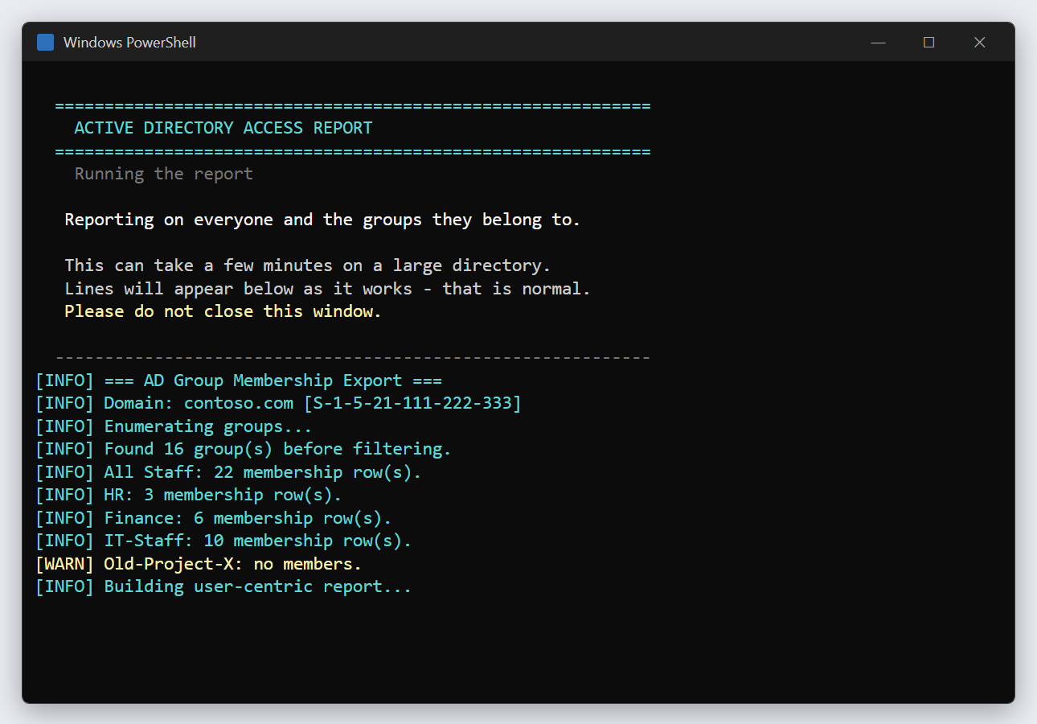
Figure 5 — The report running. Lines appearing means it is working. Do not close the window.

4. When it finishes
When the report is done, the window shows a summary and asks two quick questions. Press Enter to accept the answer in capitals (Y) for both.
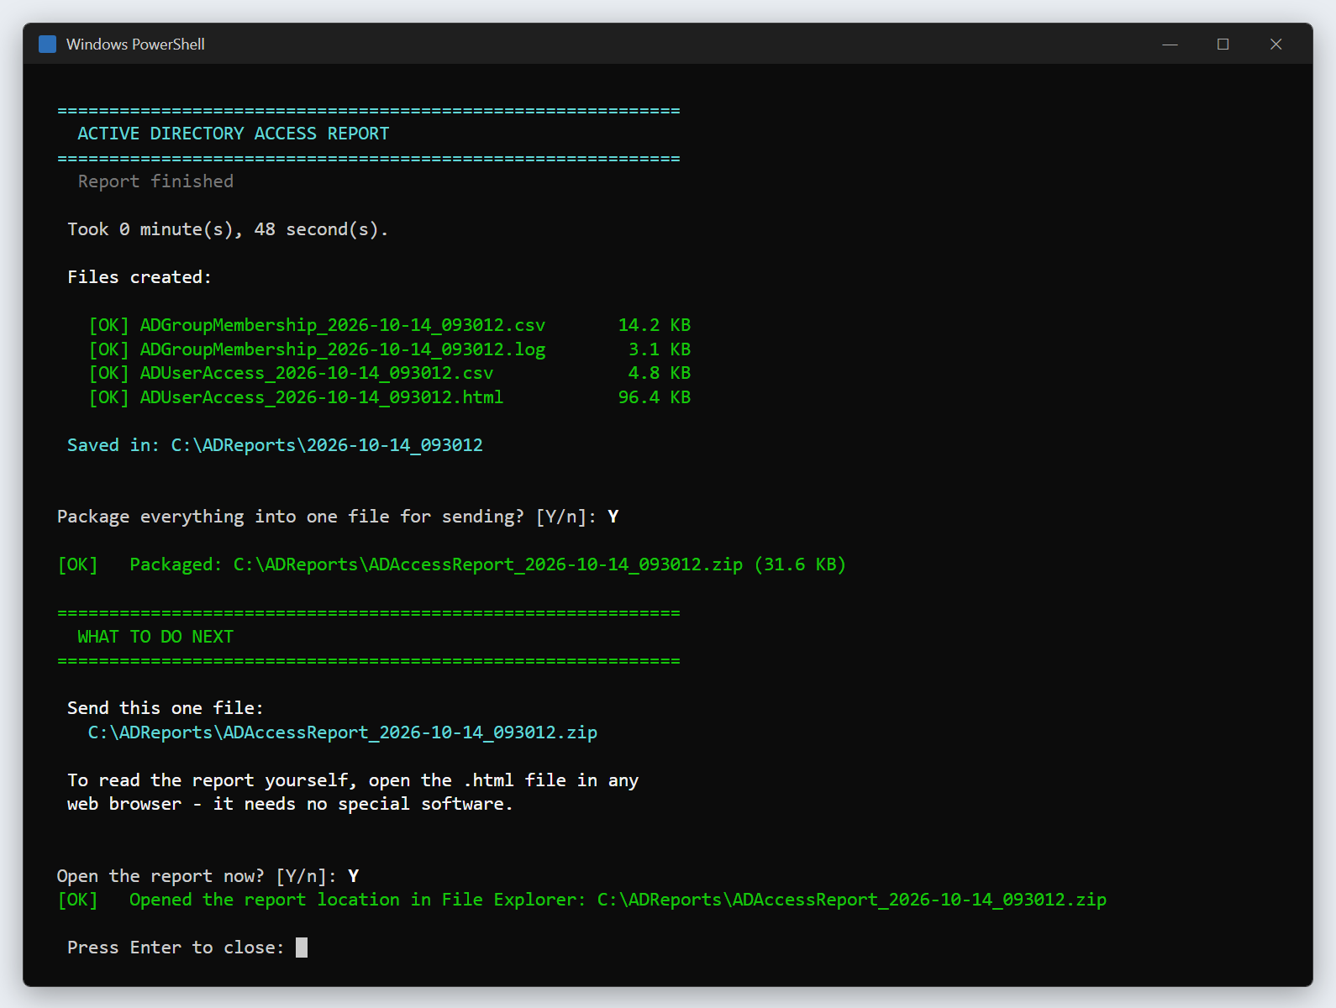
Figure 6 — The finish screen: files created, the packaged .zip, and what to send.
- Files created — four files, each with a green [OK] and a size. A red [X] means that file came out empty: run the report again.
- Package everything into one file for sending? [Y/n] — press Enter. This puts every file into a single .zip.
- WHAT TO DO NEXT — shows the one file to attach to the ticket.
- Open the report now? [Y/n] — press Enter. The report opens in your web browser.
- File Explorer opens with the .zip already highlighted — that is the file to attach.
- Press Enter to close the window when you are finished.

Where the files are
Every run gets its own folder named after the date and time, inside C:\ADReports. The .zip sits one level up, directly in C:\ADReports, so it is easy to find.
File | What it is | Who needs it
ADAccessReport_<date>.zip | Everything below, packed into one file | Attach this to the ticket
ADUserAccess_<date>.html | The report you read in a web browser (sections 5 to 8) | You
ADUserAccess_<date>.csv | One row per person, for Excel | Whoever asked, if they want a spreadsheet
ADGroupMembership_<date>.csv | One row per person per group — the raw list | Your AD admin, for deeper digging
ADGroupMembership_<date>.log | A record of what happened during the run | Your AD admin, if something went wrong

If C:\ADReports cannot be written to, the tool uses Documents\ADReports instead and says so in yellow. That is fine.
STOP The report is confidential
It lists real people and what they can get into. Attach it to the ticket — do not email it around, post it in chat, or save it to OneDrive or a shared drive.

Finding your way around the report
The report is a single web page. It needs no internet connection and no special software. At the top you will see the domain name, when it was made, a Light mode button, and four tabs:
Tab | Answers the question | Section
People | What does this person have access to, and how did they get it? | 5
Groups | Who is in this group, and how did they get in? | 6
Overlap | Which groups have the same people in them? | 7
Nesting | Which groups are inside which other groups? | 8

The number next to each tab is how many people or groups it holds.

5. People tab — what does this person have?
One card per person. Click a name to open their card and see every group they are in.
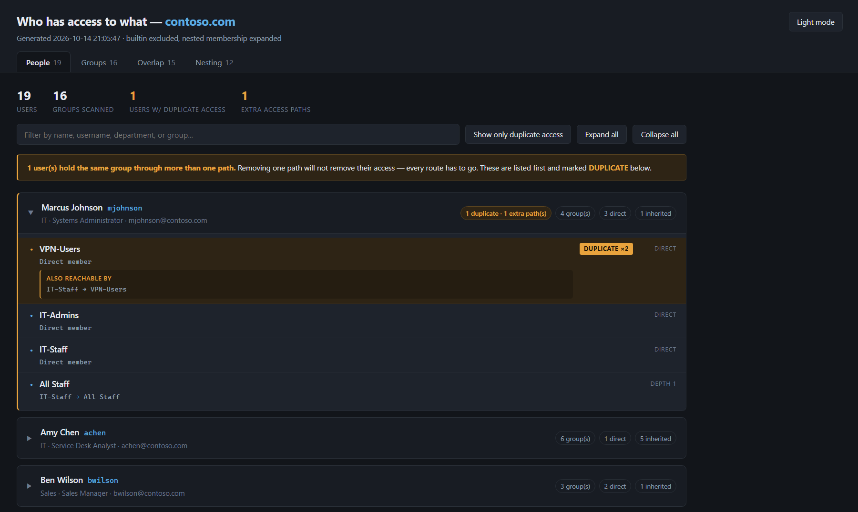
Figure 7 — The People tab, with Marcus Johnson's card open. He has VPN-Users twice.

What you are looking at
- The numbers at the top — how many people, how many groups were checked, and how many people have duplicate access.
- The filter box — type part of a name, username, department or group name. The list narrows as you type.
- Show only duplicate access — hides everyone without a duplicate. Expand all / Collapse all open or close every card.
- The yellow banner — appears when someone holds the same group by more than one route. Those people are listed first.

How did they get each group?
Under each group name, the card says how the person got it:
What the card says | What it means
Direct member | Someone added this person to the group by name.
A path, such as IT-Staff → All Staff | The person is in IT-Staff, and IT-Staff is inside All Staff, so they get All Staff too. Depth 1 means one group in between; depth 2 means two, and so on.
Primary group | Set on the account itself — almost always Domain Users. You can usually ignore it.

DUPLICATE — the same access twice
A yellow DUPLICATE ×2 badge means the person gets that group in two different ways. In the example, Marcus is in VPN-Users directly, and through IT-Staff (IT-Staff is inside VPN-Users). The box under the group, Also reachable by, shows the other route.
IMPORTANT Check for DUPLICATE before saying access has been removed
If you only remove Marcus from VPN-Users, he still has VPN through IT-Staff. Every route has to go. Section 9C walks through this.

6. Groups tab — who is in this group?
Groups are listed on the left. Click one to see its details and everyone in it on the right.
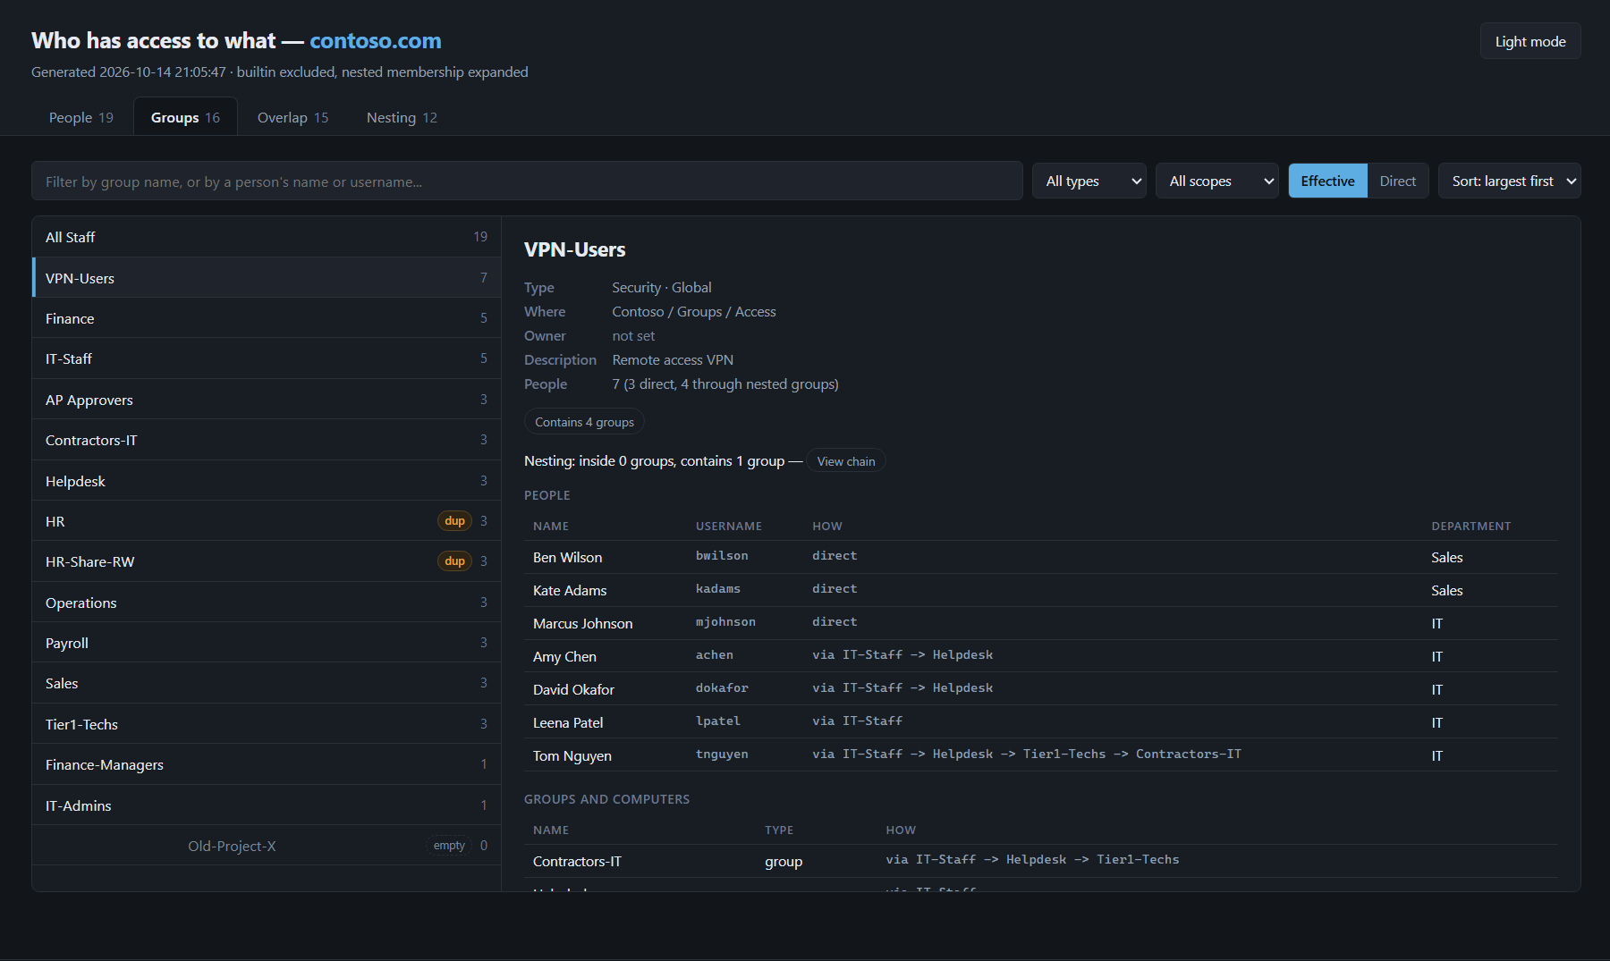
Figure 8 — The Groups tab with VPN-Users selected. The How column shows the route for each person.

The group list (left)
- Each group shows how many people are in it. Biggest first by default — change it with the Sort box.
- dup — this group has almost exactly the same people as another group (see section 7).
- empty — nobody is in this group.

The details (right)
Label | Meaning
Type | Security groups give access to things. Distribution groups are email lists only — they do not give access.
Where | Which folder (area) of Active Directory the group lives in.
Owner | The person set as the group's manager in AD, if any. Often the right person to approve changes.
People | How many people, split into direct members and people who get it through other groups.
How (column) | direct = added by name. via IT-Staff -> Helpdesk = gets it through those groups, in that order. primary group = set on the account.
Groups and computers | Groups placed inside this group, and any computer accounts that are members.

The controls along the top
- All types / All scopes — narrow the list to security or distribution groups, or to one scope. Leave them alone unless your AD admin asks.
- Effective / Direct — Effective (the default) shows everyone who really has the group, including through other groups. Direct shows only people added by name.
- View chain — jumps to the Nesting tab for this group.

7. Overlap tab — which groups share people?
Use this tab to find groups that are doing the same job, and to check who holds two groups at once. It has three views, chosen just under the filter bar: Overlapping pairs, Grid and Check a combination.

Overlapping pairs
Every pair of groups that share at least two people, most similar first. Click a pair to list the people they share.
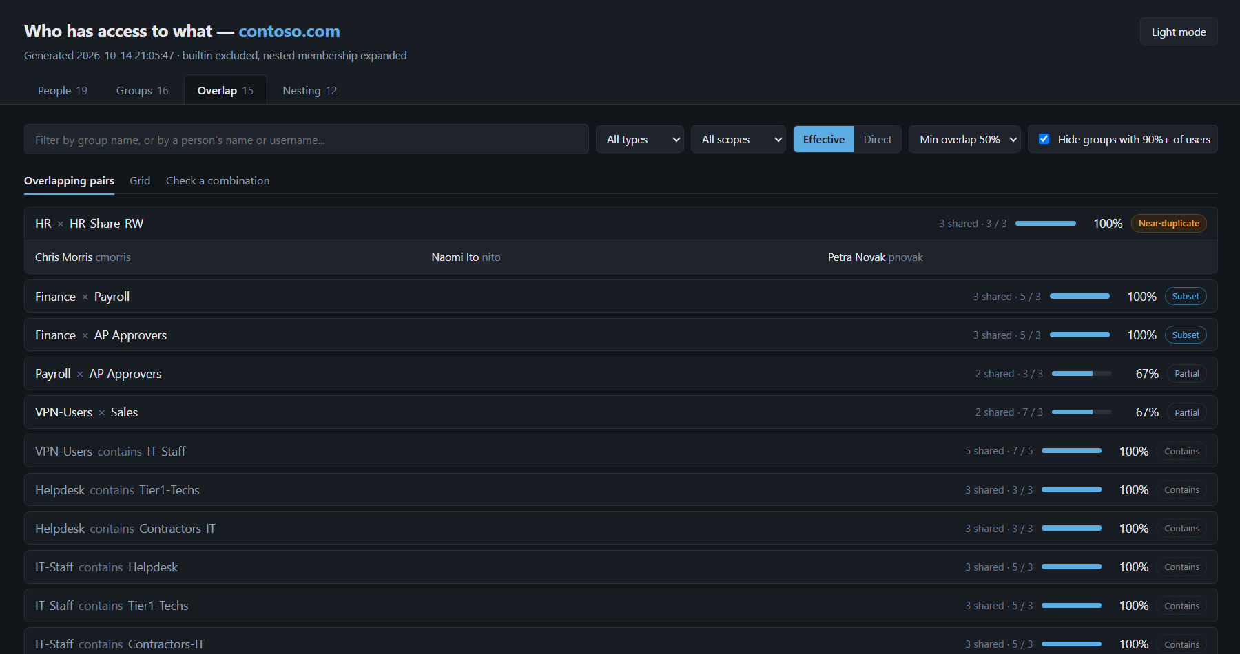
Figure 9 — Overlapping pairs. HR and HR-Share-RW have exactly the same three people.
Reading a row: 3 shared · 3 / 3 means 3 people are in both groups, and the groups have 3 and 3 members. The percentage is the shared people as a share of the smaller group.
Label | What it means | What to do
Near-duplicate | Nearly everyone in both groups is the same (90% or more of even the larger group). | Possibly the same group twice. Mention it to your AD admin as a clean-up candidate.
Subset | Everyone in the smaller group is also in the larger one. | Usually fine (for example, managers inside a department).
Partial | Some people are in both. | Nothing, unless you were asked about these two groups.
Contains (greyed) | One group is placed inside the other, so the overlap is expected. | Nothing. These are listed last.

Min overlap sets how similar a pair must be to be listed (50% by default). Hide groups with 90%+ of users hides company-wide groups such as All Staff, which overlap with everything.

Grid
A table of every group against every other group. Each number is how many people are in both; darker squares mean a bigger share. The diagonal (top-left to bottom-right) is each group's own size. Click a number to see who.
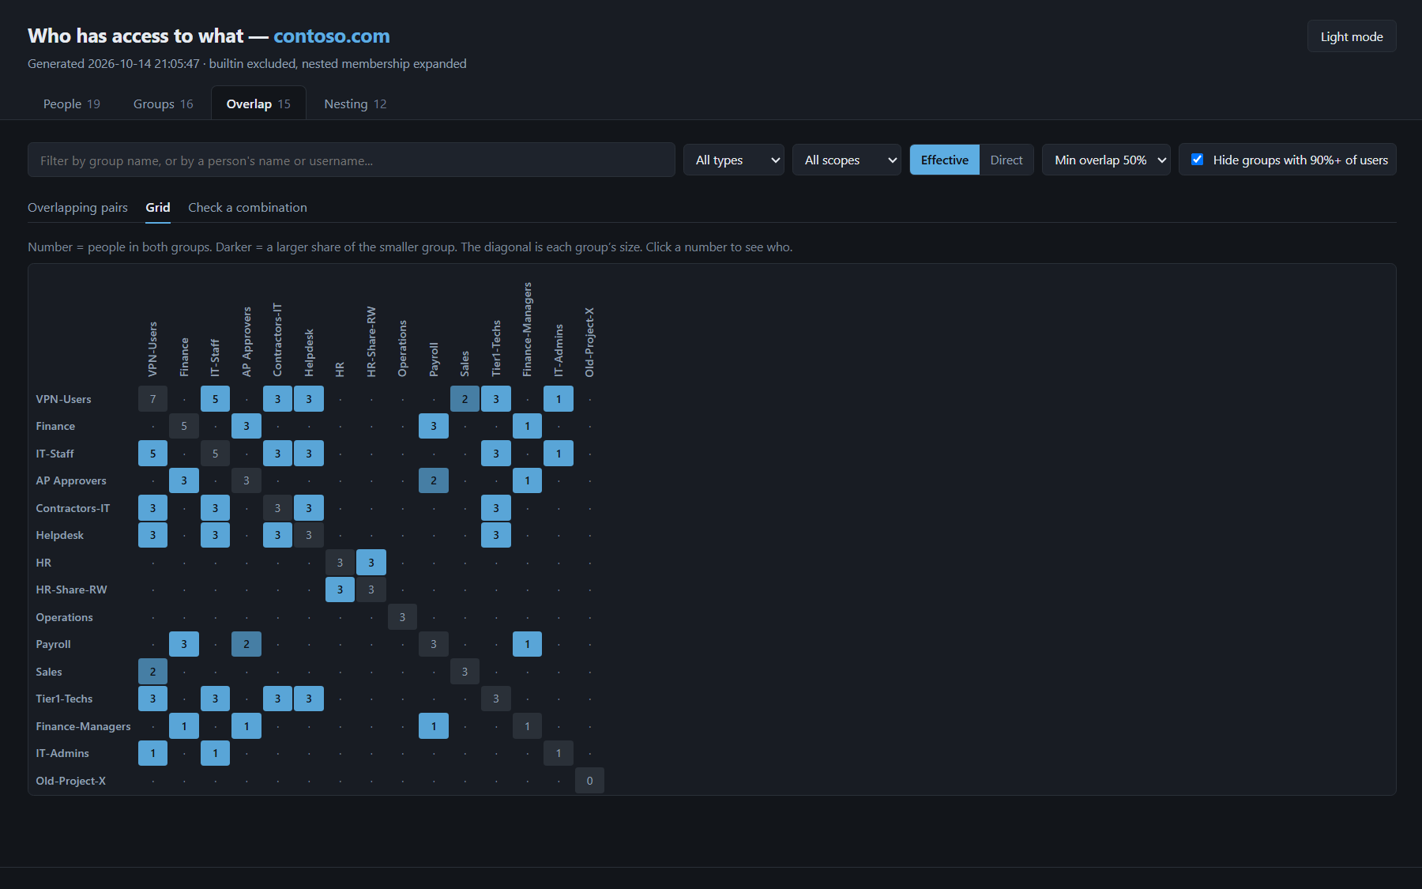
Figure 10 — The Grid view. Darker squares are groups with more people in common.
The grid appears when 40 groups or fewer are showing. On a bigger directory, type part of a group name (for example Fin) or someone's username in the filter box to narrow it down.

Check a combination
Lists the people who are in all of the groups you pick. Type a group name, click Add group, and repeat for each group. Click the × on a group to remove it.
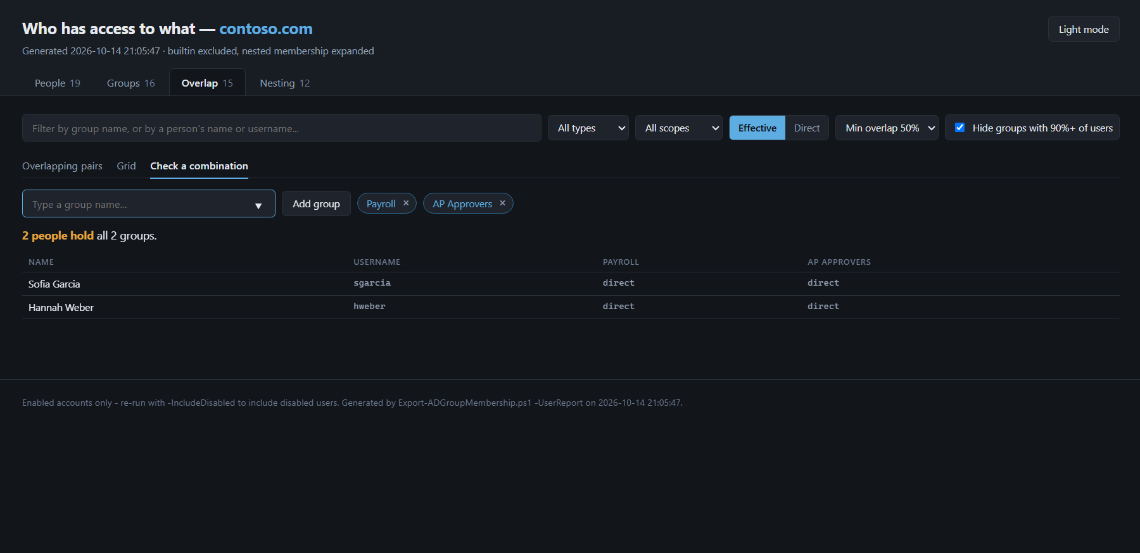
Figure 11 — Check a combination: two people hold both Payroll and AP Approvers.
TIP A classic use: who can both set up and approve payments?
In the example, Sofia Garcia and Hannah Weber are in both Payroll and AP Approvers. Auditors often ask for exactly this list.

8. Nesting tab — groups inside groups
A group can be a member of another group — like a box inside a box. Everyone in the inner group automatically gets everything the outer group gets. This tab shows those boxes, so you can see where someone's access really comes from.
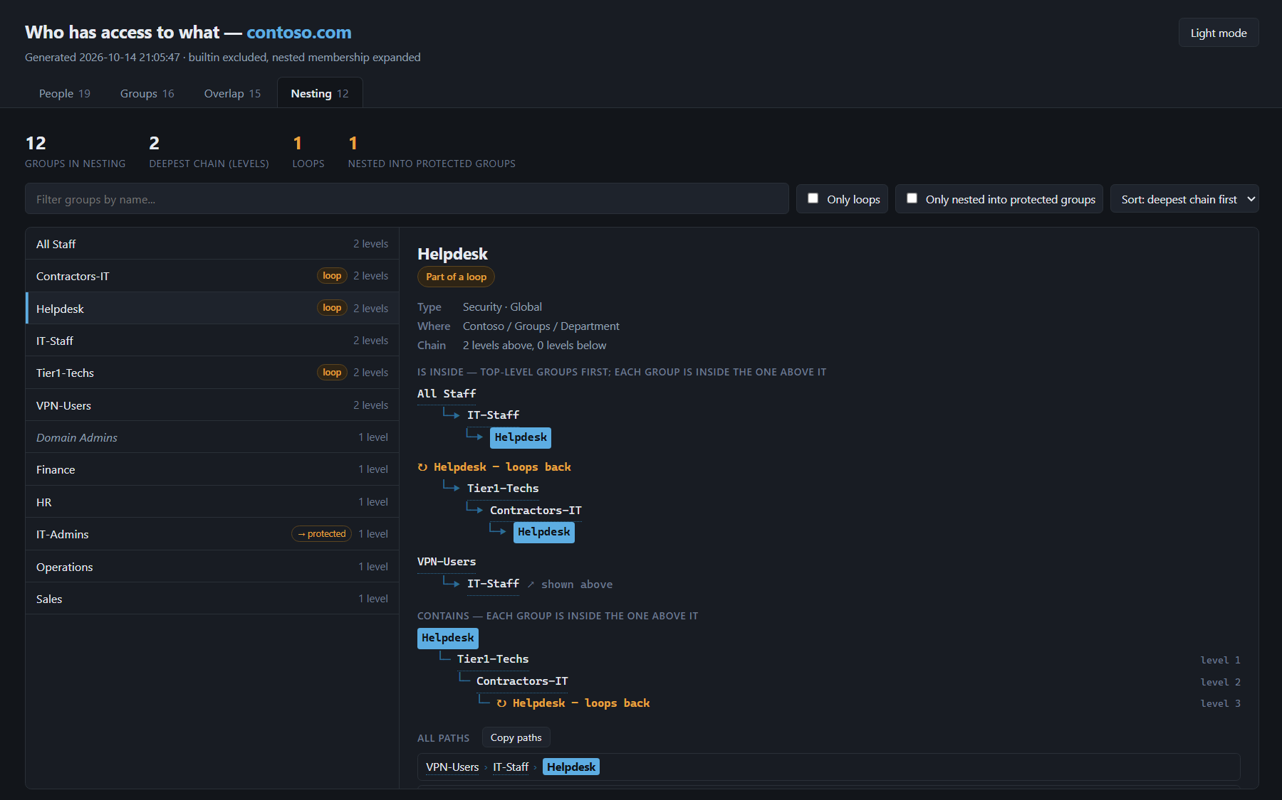
Figure 12 — The Nesting tab with Helpdesk selected. Helpdesk is part of a loop.

What you are looking at
- The numbers at the top — how many groups are involved, the deepest chain, how many loops, and how many groups sit inside a protected group such as Domain Admins.
- The list (left) — groups with their depth in levels. Badges: loop (part of a loop) and → protected (inside a protected group). Use Only loops or Only nested into protected groups to narrow the list.
- Is inside — the groups the selected group sits inside, drawn from the top down: the top-level group first, and each group is inside the one above it. The selected group is highlighted in blue. In the figure above, Helpdesk is inside IT-Staff, which is inside All Staff.
- Contains — the groups inside the selected group, and how many levels down.
- All paths / Copy paths — every complete route, one per line. Copy paths copies them so you can paste them straight into a ticket.
- shown above — that branch has already been drawn higher up, so it is not repeated.

Loops
A loop is a circle of groups that are inside each other: here Helpdesk → Tier1-Techs → Contractors-IT → Helpdesk. It is marked in orange with loops back where the circle closes. Loops do not break anything on their own, but they make access confusing and are almost always a mistake. Report them to your AD admin.

Protected groups
Protected groups are Microsoft's most powerful built-in groups — Domain Admins, Enterprise Admins, Administrators and a few others. The report recognises them even if someone has renamed them. A group shown in italics with a dashed border was outside the report's scope and was looked up only to complete the picture.
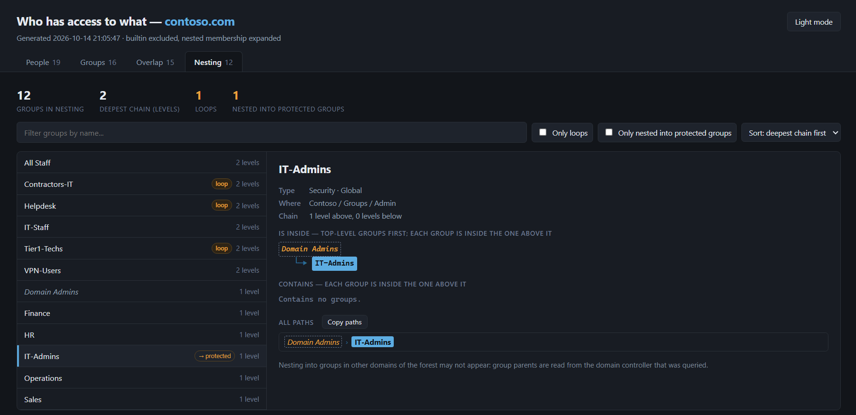
Figure 13 — IT-Admins sits inside Domain Admins, so everyone in IT-Admins is a domain admin.
STOP Anyone added to IT-Admins becomes a domain admin
A group marked → protected passes on full administrator rights. Never add people to such a group without your AD admin's approval, and flag any you did not expect.

9. Common tasks

A. Offboarding: what did this person have?
- Before the account is changed, run the report with option 1.
- On the People tab, type the person's name in the filter box and open their card.
- Note every group, and any DUPLICATE badges. Attach the .zip to the ticket as the "before" record.
- After the groups have been removed, run the report again and check their card shows only their primary group (usually Domain Users).
NOTE Disabled accounts are not listed
Once an account is disabled it disappears from the report. That does not mean its groups were removed. If you need to see a disabled account's groups, ask your AD admin to run the report with disabled accounts included.

B. "Why does Amy have access to this?"
- Open the People tab and filter for Amy.
- Find the group in her card and read the line under it: Direct member, or a path such as IT-Staff → Helpdesk.
- A path means she gets it through another group. To change it, someone has to change her membership of the first group in the path — or the nesting itself (a job for your AD admin).

C. Fully removing someone's access to a group
- Open their card on the People tab and find the group.
- If it has a DUPLICATE badge, read Also reachable by — every route listed there also has to go.
- Write every route into the ticket. Removing someone from a group that is inside another group affects everyone in it, so check with your AD admin if a route goes through another group.
- After the change, run the report again and check that the group has gone from their card.

D. Who is in Domain Admins (or another sensitive group)?
- Run the report with option 2 and type Domain Admins (add more names separated by commas).
- On the Groups tab, select the group. Keep Effective selected so people who get it through other groups are included.
- On the Nesting tab, tick Only nested into protected groups to see every group that passes on admin rights.
NOTE About built-in groups
Built-in groups are left out of the main lists to keep the report readable, but you can still ask for one by name with option 2, and the Nesting tab always shows when a group sits inside one.

E. Finding groups that might be duplicates
- Open the Overlap tab, Overlapping pairs view.
- Look for the orange Near-duplicate label. Click the pair to see who they share.
- List the pairs in a ticket for your AD admin. Do not delete or empty a group yourself.

F. Who holds two risky groups at once?
- Open the Overlap tab, Check a combination view.
- Add each group with Add group.
- The list underneath shows everyone in all of them. Copy the names into the ticket.

10. Troubleshooting
When something goes wrong, the window turns red, says THIS REPORT COULD NOT RUN, explains why, and lists What to do next. It always waits for you to press Enter, so you have time to read it or take a screenshot.
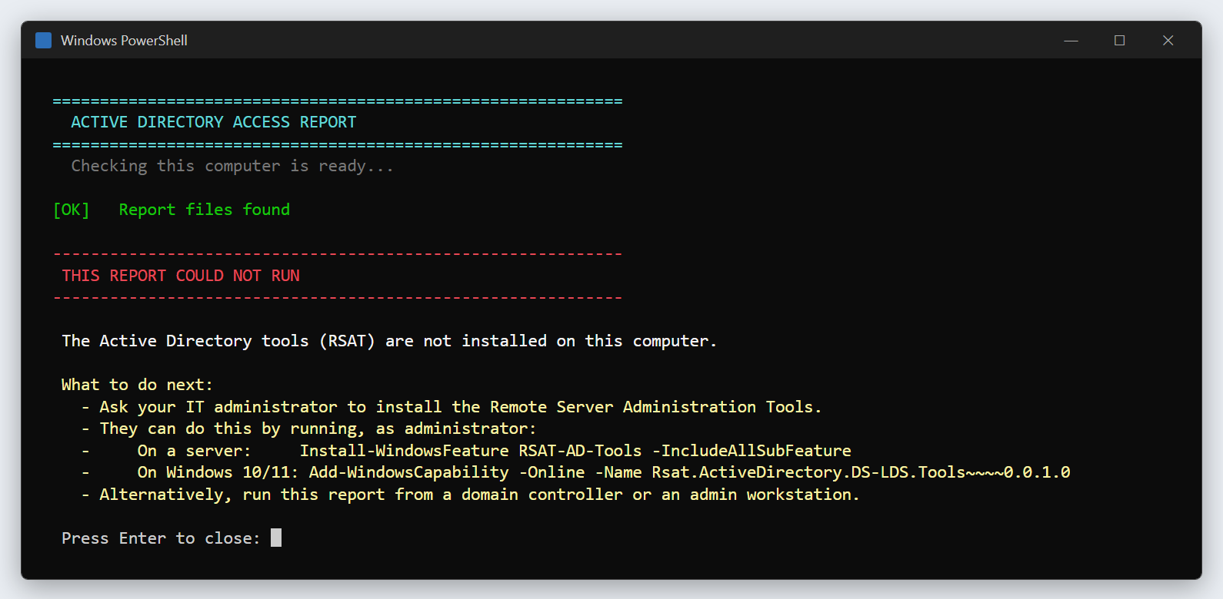
Figure 14 — An example error: the Active Directory tools are not installed on this computer.
What you see | What it means | What to do
Window flashes and closes, or Could not find Start-AccessReport.ps1 next to this file | Only part of the folder was copied. | Copy the whole folder and try again.
Blue Windows protected your PC box | Windows does not recognise the file. | Do not click through. Ask your AD admin.
The Active Directory tools (RSAT) are not installed on this computer | This computer cannot read AD. | Run it on a domain controller or admin server instead, or ask your AD admin to install the tools.
This computer could not reach an Active Directory domain controller | No connection to the domain. | Check the network or VPN, and that you signed in with a domain account. Still failing? Pass it to your AD admin.
The chosen save location is inside a cloud-synced folder | Someone set the save folder to OneDrive or similar. | Pass it to your AD admin — the normal setup never does this.
Yellow Could not write to C:\ADReports - using your Documents folder instead | You cannot write to C:\. | Nothing. Your files are in Documents\ADReports.
None of those names matched a group in your directory | The group names did not match (option 2). | Check the spelling, or use the start of the name plus *, such as Fin*.
The report stopped before it finished | Usually a brief network drop. | Run it again. If it happens twice, pass the message on screen to your AD admin.
Red [X] next to a file, or WARNING: some files are empty | A file did not save properly. | Run it again. If it happens twice, tell your AD admin.
Could not package the files | The .zip could not be made. | Right-click the report folder → Send to → Compressed (zipped) folder, and attach that.
The report looks plain, or the tabs do not work | An old browser (common on older servers). | Copy the .html file to your own PC and open it in Edge or Chrome.
Upward chains may be incomplete on the Nesting tab | The directory has more parent groups than the report looks up. | Fine for most questions. Ask your AD admin if you need the full chain.
A person is missing from the report | Their account is disabled, or they are not in any group that was included (options 2 and 3 only cover some groups). | Re-run with option 1. If still missing, check the account is enabled.
There is no .html file | Something went wrong while building the report. | Send the .log file from the report folder to your AD admin.

When to hand it to your AD admin
- The Active Directory tools are missing, or the domain cannot be reached after you checked the network and your sign-in.
- The same error happens twice in a row.
- The report shows a group → protected or a loop you were not expecting.
- You need disabled accounts included, or a different domain.
- Anyone asks you to change group membership based on what the report shows.

11. What to put in the ticket
Include | Example
The .zip file, attached | ADAccessReport_2026-10-14_093012.zip
Which option you chose, and anything you typed | Option 2: Payroll, AP Approvers
The question, and your answer in one sentence | "Marcus Johnson has VPN-Users twice — directly and through IT-Staff."
For nesting questions, the text from Copy paths | VPN-Users > IT-Staff > Helpdesk
Any yellow or red lines you saw | A screenshot of the window is fine

Safety rules
- The tool only reads. Running it is always safe and changes nothing in Active Directory.
- The report is confidential. It lists people and their access. Keep it in the ticket.
- Never save it to OneDrive, Dropbox or a shared drive. The tool refuses cloud-synced folders for a reason: files there can arrive empty.
- Do not change group membership just because of the report. Follow your normal change process, and always check for DUPLICATE first.
- Tidy up. Delete your copy from C:\ADReports when the ticket is closed, if your team's policy asks for it.

Quick reference card
Step | What to do
1. Start | Copy the whole folder (3 files). Double-click Run-AccessReport.bat.
2. Checks | Wait for three green [OK] lines. Red box? See section 10.
3. Choose | 1 = everyone (best if unsure) · 2 = named groups, separated by commas · 3 = one area
4. Wait | Lines scrolling is normal. Do not close the window.
5. Finish | Press Enter to package (Y) and Enter to open (Y). Explorer highlights the .zip.
6. Attach | C:\ADReports\ADAccessReport_<date>.zip — plus option used, question and answer.

Tab | Use it for
People | Everything one person has, and how they got it.
Groups | Everyone in one group, and how they got in. Effective = all routes, Direct = added by name.
Overlap | Groups with the same people · grid of shared members · who holds several groups at once.
Nesting | Groups inside groups, loops, and groups inside Domain Admins. Copy paths for tickets.

You see | It means
DUPLICATE ×2 | Same group by two routes — removing one will not remove the access.
via A -> B / A → B | Gets the group through A, then B.
Near-duplicate | Two groups with nearly identical members — a clean-up candidate.
loop | Groups inside each other in a circle — report it.
→ protected | Inside Domain Admins or similar — members get admin rights.
Dashed / italic group | Outside the report's scope; shown for context only.

STOP Hand it to your AD admin if…
RSAT is missing · the domain cannot be reached · the same error happens twice · you see an unexpected loop or → protected · you are asked to change groups.

